Getting Theseus Cores Polyphase Filter Bank Channelizer Working in RFNoC on an X310
Phase 4 Ground May 23, 2019
by Abraxas3d

Update and upgrade your Ubuntu system.
Make sure no other gnuradio installations are lurking about from packages.
Install git and pybombs.

We’re going to make an RFNoC prefix using pybombs.

In order to install theseus-cores recipes for RFNoC, you must use:
pybombs auto-config
pybombs recipes add-defaults

as described on this page:
https://github.com/gnuradio/pybombs/blob/master/README.md

Instead of:
$ pybombs recipes add gr-recipes git+https://github.com/gnuradio/gr-recipes.git
$ pybombs recipes add ettus git+https://github.com/EttusResearch/ettus-pybombs.git

Which is described in the “Create development environment using PyBOMBS” section of
https://kb.ettus.com/Getting_Started_with_RFNoC_Development

And in the Pybombs section of
https://gitlab.com/theseus-cores/theseus-cores

Specifically, line 2 will steer you a bit wrong.
Line 2 says “2. Update pybombs recipe repos (specifically gr-recipes, gr-etcetera, and ettus)”

If you update the repositories the old way, then you will get a recipe not found error.

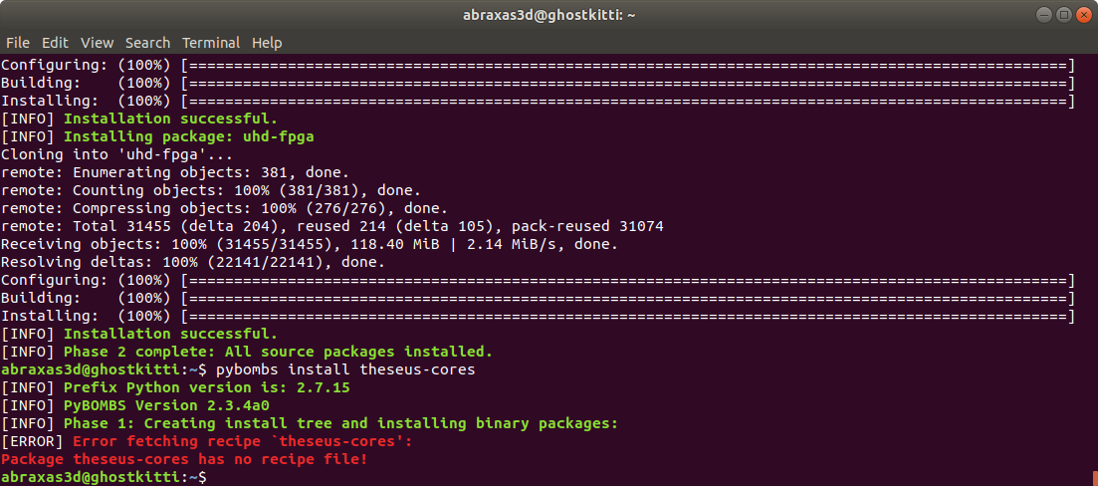

If you install the recipes with
pybombs auto-config
pybombs recipes add-defaults
Then the recipe for Theseus Cores should be found and the module will install.

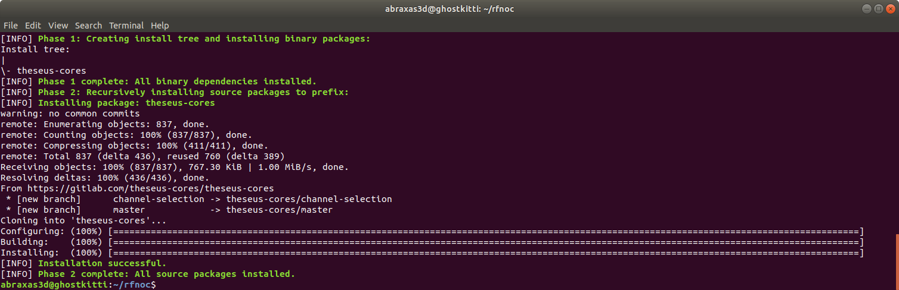

Connect a USRP. We have an X310 from Ettus Research (thank you Ettus for the fantastic support!

uhd_config_info –version

returned expected installation version

source setup_env.sh

sudo uhd_images_downloader

Successfully downloaded images.

uhd_usrp_probe

resulted in an error, but it was expected.

[INFO] [UHD] linux; GNU C++ version 7.4.0; Boost_106501; UHD_3.15.0.git-134-gcea82b42
[INFO] [X300] X300 initialization sequence...
Error: RuntimeError: Expected FPGA compatibility number 36, but got 33:
The FPGA image on your device is not compatible with this host code build.
Download the appropriate FPGA images for this version of UHD.
Please run:

"/home/abraxas3d/rfnoc/lib/uhd/utils/uhd_images_downloader.py"

Then burn a new image to the on-board flash storage of your
USRP X3xx device using the image loader utility. Use this command:

"/home/abraxas3d/rfnoc/bin/uhd_image_loader" --args="type=x300,addr=192.168.10.2"

For more information, refer to the UHD manual:

http://files.ettus.com/manual/page_usrp_x3x0.html#x3x0_flash

abraxas3d@ghostkitti:~/rfnoc$ uhd_image_loader –args="type=x300,addr=192.168.10.2"

[INFO] [UHD] linux; GNU C++ version 7.4.0; Boost_106501; UHD_3.15.0.git-134-gcea82b42
Unit: USRP X310 (30A8CE8, 192.168.10.2)
FPGA Image: /home/abraxas3d/rfnoc/share/uhd/images/usrp_x310_fpga_HG.bit
-- Initializing FPGA loading...successful.
-- Loading HG FPGA image: 100% (121/121 sectors)
-- Finalizing image load...successful.
Power-cycle the USRP X310 to use the new image.

X310 was power cycled and uhd_usrp_probe successfully returned information about the USRP and the RFNoC blocks on the device.
RFNoC blocks on this device:
| | |
| | | * DmaFIFO_0
| | | * Radio_0
| | | * Radio_1
| | | * DDC_0
| | | * DDC_1
| | | * DUC_0
| | | * DUC_1

A simple flowgraph was made.

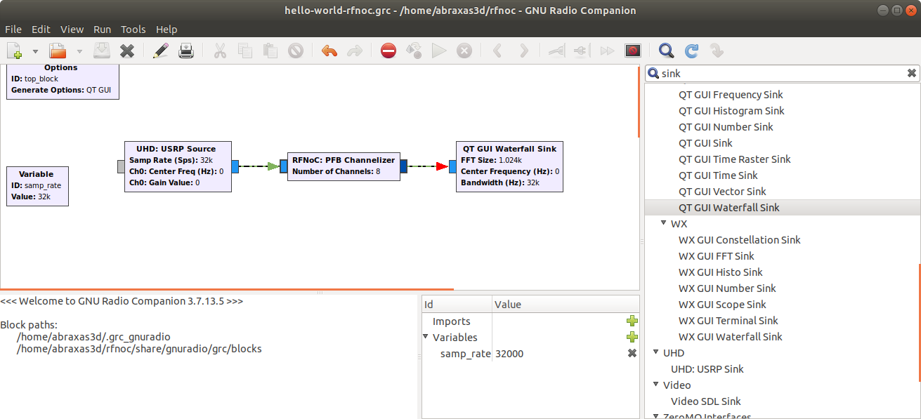

We learned about Device 3.

We got the ports to match with a single channel in the channelizer.
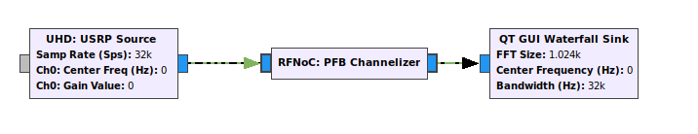
We got:
RuntimeError: Cannot find a block for ID: pfbchannelizer

Trying an example from RFNoC (fosphor) we got:

RuntimeError: Cannot find a block for ID: Window

So RFNoC blocks don’t “just work” or “just move” to the USRP.
We have to build the image every time we want new blocks. This is explained further down on the Getting Started with RFNoC page. I assumed it was for custom blocks only, but it is for anything not “built in” with the default image.

We need to build our image.
uhd_image_builder.py is the right tool for this job.
Following the Getting Started with RFNoC guide from Ettus:
abraxas3d@ghostkitti:~/rfnoc/src/uhd-fpga/usrp3/tools/scripts$ ./uhd_image_builder.py pfbchannelizer -d x310 -t X310_RFNOC_HG -m 5 --fill-with-fifos
--Using the following blocks to generate image:
* pfbchannelizer
Adding CE instantiation file for 'X310_RFNOC_HG'
changing temporarily working directory to /home/abraxas3d/rfnoc/src/uhd-fpga/usrp3/tools/scripts/../../top/x300
Setting up a 64-bit FPGA build environment for the USRP-X3x0...
- Vivado: Version 2018.3 not found in /opt/Xilinx/Vivado (ERROR.. Builds and simulations will not work)
Use the --vivado-path option to override the search path

Vivado 2018.2 was installed, but Vivado 2018.3 was not.
Vivado 2018.3 was installed.

However, it installs in tools/Xilinx/Vivado, and not in opt/Xilinx/Vivado.
The script could not seem to find it.

abraxas3d@ghostkitti:~/rfnoc/src/uhd-fpga/usrp3/tools/scripts$ ./uhd_image_builder.py pfbchannelizer -d x310 -t X310_RFNOC_HG -m 5 --fill-with-fifos
--Using the following blocks to generate image:
* pfbchannelizer
Adding CE instantiation file for 'X310_RFNOC_HG'
changing temporarily working directory to /home/abraxas3d/rfnoc/src/uhd-fpga/usrp3/tools/scripts/../../top/x300
Setting up a 64-bit FPGA build environment for the USRP-X3x0...
- Vivado: Version 2018.3 not found in /opt/Xilinx/Vivado (ERROR.. Builds and simulations will not work)
Use the --vivado-path option to override the search path

Ok we tried adding the suggested option.

abraxas3d@ghostkitti:~/rfnoc/src/uhd-fpga/usrp3/tools/scripts$ ./uhd_image_builder.py pfbchannelizer -d x310 -t X310_RFNOC_HG -m 5 --fill-with-fifos --vivado-path /tools/Xilinx/Vivado
usage: uhd_image_builder.py [-h] [-I INCLUDE_DIR [INCLUDE_DIR ...]] [-y YML]
[-m MAX_NUM_BLOCKS] [--fill-with-fifos]
[-o OUTFILE] [--auto-inst-src AUTO_INST_SRC]
[-d DEVICE] [-t TARGET] [-g] [-c]
[blocks [blocks ...]]
uhd_image_builder.py: error: unrecognized arguments: --vivado-path /tools/Xilinx/Vivado

Ok the suggested option (--vivado-path) is unrecognized. It must be an option for something else.
Advice from Phase 4 Ground #fpga was that RFNoC really only uses Vivado 2017.4. That’s the only Vivado supported. The scripts seem to be calling for 2018.3, but the Getting Started with RFNoC (https://kb.ettus.com/Getting_Started_with_RFNoC_Development) website does call out 2017.4 specifically, and does say the default location is /opt/Xilinx/Vivado

So Vivado 2017.4 was installed to see if this solved the problem.
This did not solve the problem. uhd_image_builder.py still wants 2018.3.
2018.3 was uninstalled from /tools/Xilinx/Vivado

To uninstall when you don’t have a launcher, do this:
cd /tools/Xilinx/.xinstall/Vivado_2018.3/
sudo ./xsetup -Uninstall
2018.3 was reinstalled to /opt/Xilinx/Vivado
./uhd_image_builder.py pfbchannelizer -d x310 -t X310_RFNOC_HG -m 5 –fill-with-fifos

now runs, but failed to find a license file for Synthesis with the following error:

“Failed to get the license for feature 'Synthesis' and/or device 'xc7k410t'.”

Synthesis was added with a 30 day evaluation license. There’s an existing full (donated) license, but it’s not clear what’s wrong, and it will take some time to figure out. The evaluation license got past the error.

There was another error. The arguments to the uhd_image_builder were wrong. I was using the RFNoC Getting Started style, but there’s instructions in the Theseus Cores GitLab RFNoC README, and they are different.

The template from Theseus Cores GitLab RFNoC README is:
./uhd_image_builder.py -d x300 -t X300_RFNOC_HG -y <prefix-src>/theseus-cores/fpga-rfnoc/examples/basic-dsp-utils.yml -I <prefix-src>/theseus-cores/fpga-rfnoc/dsp-utils
This was modified to:
sudo ./uhd_image_builder.py -d x310 -t X310_RFNOC_HG -y /home/abraxas3d/rfnoc/src/theseus-cores/fpga-rfnoc/examples/basic-dsp-utils.yml -I /home/abraxas3d/rfnoc/src/theseus-cores/fpga-rfnoc/dsp-utils
But the basic-dsp-utils.yml doesn’t list the channelizer block, and it is not in the dsp-utils include directory. I think this is just going to build the blocks in that list and only look for them in that include directory? Here’s the .yml file:
cat basic-dsp-utils.yml

# Block Definitions

- block: axi_fifo_loopback
hints:
- slota
- default

- block: axi_fifo_loopback

- block: ddc
parameters:
NUM_CHAINS: 2
NOC_ID: 64'hDDC0_0000_0000_0002
hints:
- ddc2

- block: duc
parameters:
NUM_CHAINS: 2
NOC_ID: 64'hD0C0_0000_0000_0002
hints:
- duc2

- block: ducddc
parameters:
NUM_CHAINS: 1
NOC_ID: 64'hD0C0_DDC0_0000_0001
DUC_NUM_HB: 1
DUC_CIC_MAX_INTERP: 8
DDC_NUM_HB: 1
DDC_CIC_MAX_DECIM: 8

- block: ddc_1_to_n
parameters:
NOC_ID: 64'hDDC0_1020_2000_0000
NUM_CHAINS: 2
NUM_HB: 2
CIC_MAX_DECIM: 32

So, letting this run to see if it works. I don’t expect the channelizer to get included. Once we have an image, we load the image.

Unfortunately, it failed. Here’s the error messages:

[00:18:58] Executing Tcl: opt_design -directive NoBramPowerOpt
[00:18:58] Starting Logic Optimization Command
[00:18:58] Current task: Logic Optimization +++ Current Phase: Starting
[00:18:58] Current task: Logic Optimization +++ Current Phase: Finished
[00:18:58] Starting DRC Task
ERROR: [DRC MDRV-1] Multiple Driver Nets: Net bus_clk_gen/inst/CLK_OUT4 has multiple drivers: radio_clk_gen/inst/clkout1_buf/O, and bus_clk_gen/inst/clkout4_buf/O.
ERROR: [DRC MDRV-1] Multiple Driver Nets: Net radio_reset_sync/reset_double_sync/synchronizer_false_path/value[9]_9 has multiple drivers: ce_reset_sync/reset_double_sync/synchronizer_false_path/stages[9].value_reg[9][0]/Q, and radio_reset_sync/reset_double_sync/synchronizer_false_path/stages[9].value_reg[9][0]/Q.
ERROR: [Vivado_Tcl 4-78] Error(s) found during DRC. Opt_design not run.
ERROR: [Common 17-39] 'opt_design' failed due to earlier errors.
[00:19:04] Current task: DRC +++ Current Phase: Starting
[00:19:04] Current task: DRC +++ Current Phase: Finished
[00:19:04] Process terminated. Status: Failure

========================================================
Warnings: 1352
Critical Warnings: 39
Errors: 4

Makefile.x300.inc:106: recipe for target 'bin' failed
make[1]: *** [bin] Error 1
make[1]: Leaving directory '/home/abraxas3d/rfnoc/src/uhd-fpga/usrp3/top/x300'
Makefile:112: recipe for target 'X310_RFNOC_HG' failed
make: *** [X310_RFNOC_HG] Error 2

Re-ran the command with clean option -c
sudo ./uhd_image_builder.py -d x310 -t X310_RFNOC_HG -c -y /home/abraxas3d/rfnoc/src/theseus-cores/fpga-rfnoc/examples/basic-dsp-utils.yml -I /home/abraxas3d/rfnoc/src/theseus-cores/fpga-rfnoc/dsp-util

No change, same error.

Asked Theseus Cores for help!
Recommendation:
“Also, theseus-cores project has a fork of uhd-fpga that I HAVE tested. Perhaps if you feel so inclined, add the fork as a remote and switch to my branch there...
1. Inside uhd-fpga repo: `git remote add theseus https://github.com/theseus-cores/fpga.git`
2. `git fetch theseus`
3. `git checkout choose-any-oot-folder`
That really ought to work
I'd honestly recommend starting by using my uhd-fpga fork to just see if you can get that to build”
OK so we try it!

git clone --recursive https://gitlab.com/theseus-cores/theseus-uhd-builder

here is the README:
# Tools to Organize and Build UHD Images

This repo maintains compatible configurations of uhd-fpga and theseus-cores.

To use this code in a RFNoC build, point the UHD Out-Of-Tree build to
one (or more) of the subdirectories here to build the IP and include
relevant fpga-src for these modules as the `-I` include-dirs argument.

The valid modules here are:
- src/theseus-cores/dsp-utils
- src/theseus-cores/m2_channelizer

Many of the noc blocks have configurable parameters. It is recommended to build the FPGA image by specifing a YML file with the desired parameters (see the `examples` subfolder here for configuration examples).

# Using Git Submodules

To clone this repo fresh: `git clone --recursive https://gitlab.com/theseus-cores/theseus-uhd-builder.git`

This will properly clone into the corresponding git submodules using the recursive flag.

If you've clone the repo and need to initialize or re-initialize the submodules: `git submodule update --init`

# Example RFNoC Build

To build an RFNOC FPGA image with components from the "dsp-utils" subproject, you can use refer to the example build-config YML [build-configs/basic-dsp-utils.yml](build-configs/basic-dsp-utils.yml).

1. First, install Vivado 2017.4 as per uhd-fpga installation instructions
2. Run the UHD image builder (this is set up to be run straight from the root directory of the theseus-uhd-builder repo): `python src/uhd-fpga/usrp3/tools/scripts/uhd_image_builder.py -d x300 -t X300_RFNOC_HG -y build-configs/basic-dsp-utils.yml -I src/theseus-cores/fpga-rfnoc/dsp-utils`

Change to this directory:
abraxas3d@ghostkitti:~/theseus-uhd-builder/src/uhd-fpga/usrp3/tools/scripts$

here is our new uhd_image_builder.py!

Ok, back to root directory of theseus-uhd-builder and run the script. I changed from 300 to 310.
python src/uhd-fpga/usrp3/tools/scripts/uhd_image_builder.py -d x310 -t X310_RFNOC_HG -y build-configs/basic-dsp-utils.yml -I src/theseus-cores/fpga-rfnoc/dsp-utils

It built!

To load the image, the Getting Started with RFNoC has this as a template:

uhd_image_loader --args "type=x300,addr={IP_ADDRESS}" --fpga-path {USER_PREFIX}/src/uhd-fpga/usrp3/top/x300/build/usrp_x310_fpga_RFNOC_HG.bit

So it was modified for what we just created with the theseus-cores uhd_image_builder.py.

uhd_image_loader --args "type=x300,addr=192.168.10.2" –fpga-path /home/abraxas3d/theseus-uhd-builder/src/uhd-fpga/usrp3/top/x300/build/usrp_x310_fpga_RFNOC_HG.bit

/home/abraxas3d/rfnoc/bin/uhd_image_loader --args "type=x300,addr=192.168.10.2" --fpga-path /home/abraxas3d/theseus-uhd-builder/src/uhd-fpga/usrp3/top/x300/build/usrp_x310_fpga_RFNOC_HG.bit

This succeeded. X310 was power cycled to use the new image.

uhd_find_devices

[INFO] [UHD] linux; GNU C++ version 7.4.0; Boost_106501; UHD_3.15.0.git-1-gf83faf28
--------------------------------------------------
-- UHD Device 0
--------------------------------------------------
Device Address:
serial: 30A8CE8
addr: 192.168.10.2
fpga: HG
name:
product: X310
type: x300

uhd_usrp_probe

| | _____________________________________________________
| | /
| | | RFNoC blocks on this device:
| | |
| | | * DmaFIFO_0
| | | * Radio_0
| | | * Radio_1
| | | * FIFO_0
| | | * FIFO_1
| | | * Block_0
| | | * DUC_0
| | | * DUCDDC_0
| | | * DDC1TON_0

Above is the theseus-cores image we made, loaded on the device. Below is the stock image from earlier in the process.

Comparing the list of RFNoC blocks in the stock image below to the theseus-cores image above, we can see new blocks in the theseus-cores image and that there are blocks that are now missing from the stock image.
| | _____________________________________________________
| | / RFNoC blocks on this device:
| | |
| | | * DmaFIFO_0
| | | * Radio_0
| | | * Radio_1
| | | * DDC_0
| | | * DDC_1
| | | * DUC_0
| | | * DUC_1

We now go back to GNU Radio Companion and see if the RFNoC blocks can be placed on the flowgraph. We tried the example flowgraph called rfnoc_ddc_channelizer, and it ran! This is the first successful flowgraph in RFNoC. We tried rfnoc_rational_resampler, and it ran too!

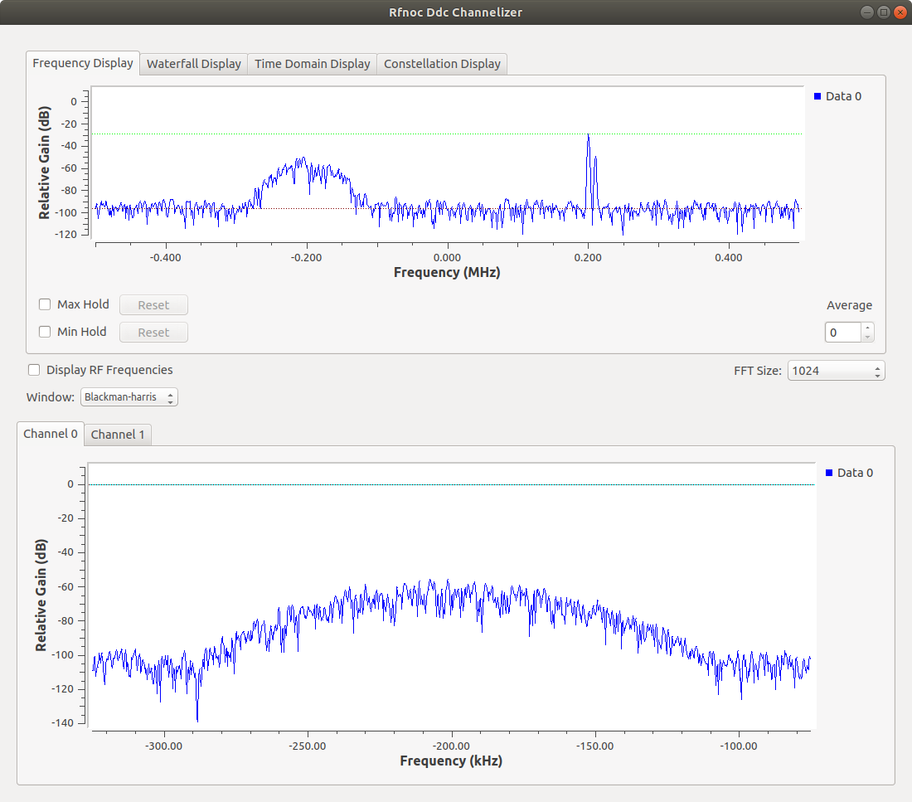
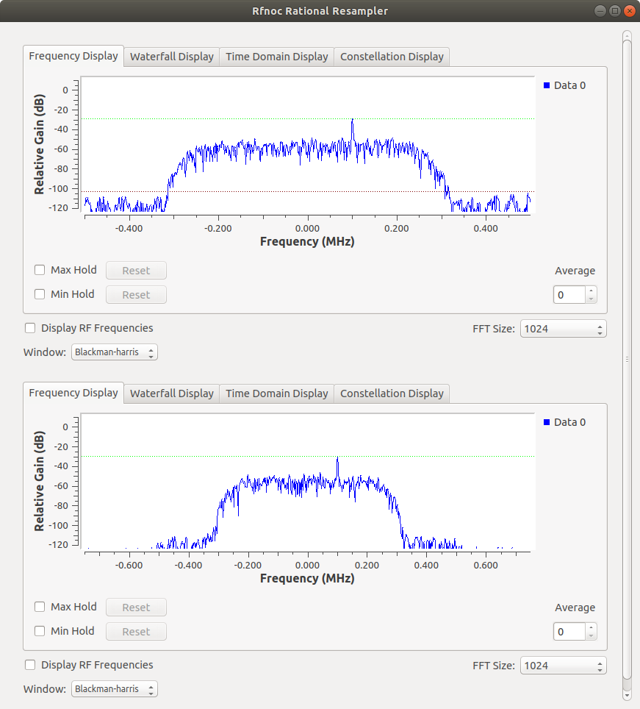

We tried the rfnoc_pfb_channelizer, knowing that we had not yet built the polyphase filterbank block, and as expected, gnu radio companion could not find this block, and did not run.

File "/home/abraxas3d/rfnoc/lib/python2.7/dist-packages/theseus/theseus_swig.py", line 721, in make
return _theseus_swig.pfbchan_make(dev, block_select, device_select)
RuntimeError: Cannot find a block for ID: pfbchannelizer
Now, we try and build the polyphase filterbank channelizer.

Start with the previous successful image builder command.

python src/uhd-fpga/usrp3/tools/scripts/uhd_image_builder.py -d x310 -t X310_RFNOC_HG -y build-configs/basic-dsp-utils.yml -I src/theseus-cores/fpga-rfnoc/dsp-utils

Let’s look at that yml file.
abraxas3d@ghostkitti:~/rfnoc/src/theseus-cores/fpga-rfnoc/examples$ cat basic-dsp-utils.yml
# Block Definitions

- block: axi_fifo_loopback
hints:
- slota
- default

- block: axi_fifo_loopback

- block: ddc
parameters:
NUM_CHAINS: 2
NOC_ID: 64'hDDC0_0000_0000_0002
hints:
- ddc2

- block: duc
parameters:
NUM_CHAINS: 2
NOC_ID: 64'hD0C0_0000_0000_0002
hints:
- duc2

- block: ducddc
parameters:
NUM_CHAINS: 1
NOC_ID: 64'hD0C0_DDC0_0000_0001
DUC_NUM_HB: 1
DUC_CIC_MAX_INTERP: 8
DDC_NUM_HB: 1
DDC_CIC_MAX_DECIM: 8

- block: ddc_1_to_n
parameters:
NOC_ID: 64'hDDC0_1020_2000_0000
NUM_CHAINS: 2
NUM_HB: 2
CIC_MAX_DECIM: 32

Here is the location of the folders containing the dsp-utils and the m2_channelizer, which are the two modules in this version of theseus-cores.
abraxas3d@ghostkitti:~/rfnoc/src/theseus-cores/fpga-rfnoc$ ls
dsp-utils examples LICENSE m2_channelizer README.md testbenches

In dsp-utils, we have:
Makefile.inc noc_block_ddc_1_to_n.v noc_block_ducddc.v

and in m2_channelizer, we have:
Makefile.inc noc_block_channelizer.v

If we drop the noc_block_ from before the channelizer.v, then it matches the format of the dsp-utils.

basic-dsp-utils.yml was copied to channelizer.yml.
There are no parameters for the channelizer yet, according to the detailed description in the main repository:
m2_channelizer/noc_block_channelizer.v
Summary
The M/2 channelizer (i.e., "pfbchan") implements the polyphase channelizer based on the GRCon 2017 presentation.
The output rate of an M/2 channelizer is 2x the input sample rate for each channel, which allows for a far sharper passband rolloff and perfect reconstruction of output subchannels. The channelizer may use a selectable number of channels at run time by programming different taps into the FPGA core (8, 16, 32, 64, 128, 256, 1024, 2048). See python code and software for details.
As implemented now (4/24/2019), the channelizer does not yet downselect channels in the FPGA to reduce output data rate as needed. Furthermore, all channels are interleaved and need to be reconstructed on the output. The gr-theseus gnuradio flowgraph example demonstrates a simple de-interleaving process using vector outputs in a flowgraph.
Parameters
No parameters available yet -- TODO: implement generate options to reduce/increase resource usage based on desired channelizer size.

The two dsp-utils blocks were removed from channelizer.yml.

# Block Definitions

- block: axi_fifo_loopback
hints:
- slota
- default

- block: axi_fifo_loopback

- block: ddc
parameters:
NUM_CHAINS: 2
NOC_ID: 64'hDDC0_0000_0000_0002
hints:
- ddc2

- block: duc
parameters:
NUM_CHAINS: 2
NOC_ID: 64'hD0C0_0000_0000_0002
hints:
- duc2

And then a channelizer block reference was added to channelizer.yml

# Block Definitions

- block: axi_fifo_loopback
hints:
- slota
- default

- block: axi_fifo_loopback

- block: ddc
parameters:
NUM_CHAINS: 2
NOC_ID: 64'hDDC0_0000_0000_0002
hints:
- ddc2

- block: duc
parameters:
NUM_CHAINS: 2
NOC_ID: 64'hD0C0_0000_0000_0002
hints:
- duc2

- block: channelizer

Now we build this new image described by this new yml file with the uhd_image_builder in the new theseus-cores install.

python src/uhd-fpga/usrp3/tools/scripts/uhd_image_builder.py -d x310 -t X310_RFNOC_HG -y build-configs/channelizer.yml -I src/theseus-cores/fpga-rfnoc/m2_channelizer

This succeeded.

Next, load the image.

/home/abraxas3d/rfnoc/bin/uhd_image_loader --args "type=x300,addr=192.168.10.2" --fpga-path /home/abraxas3d/theseus-uhd-builder/src/uhd-fpga/usrp3/top/x300/build/usrp_x310_fpga_RFNOC_HG.bit

Hey it made it in there!

| | _____________________________________________________
| | /
| | | RFNoC blocks on this device:
| | |
| | | * DmaFIFO_0
| | | * Radio_0
| | | * Radio_1
| | | * FIFO_0
| | | * FIFO_1
| | | * Block_0
| | | * DUC_0
| | | * pfbchannelizer_0

And it worked!
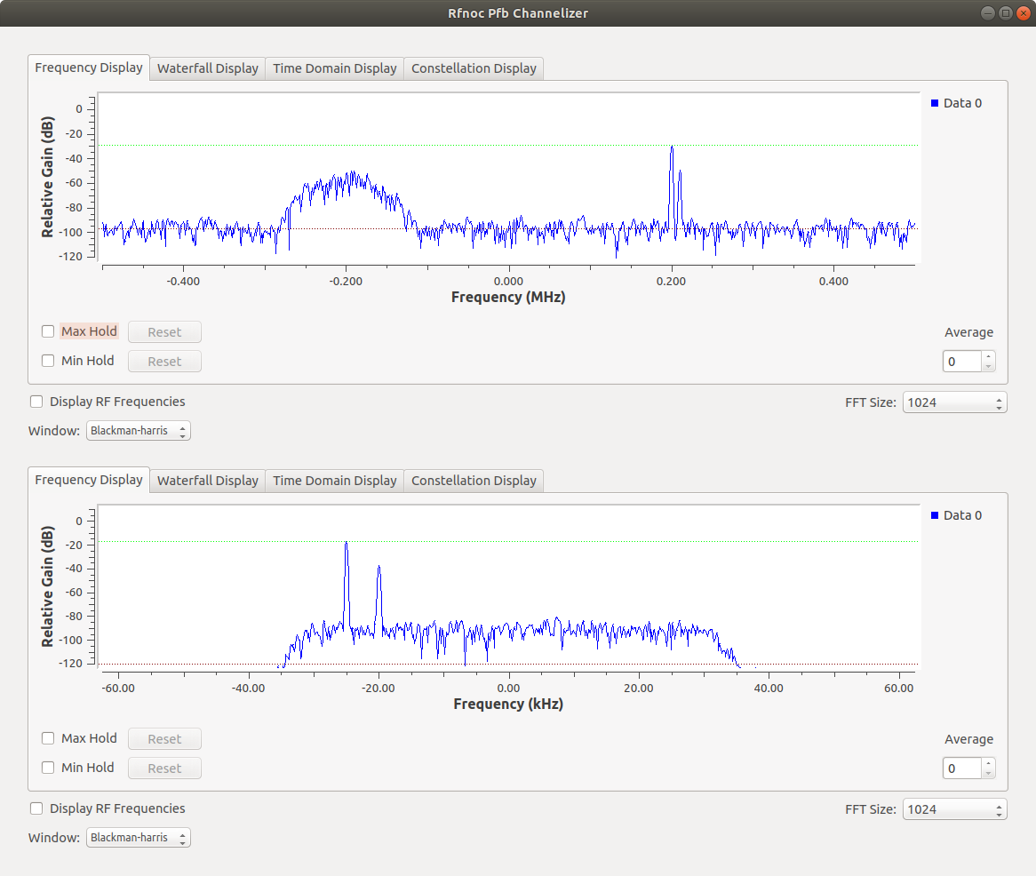

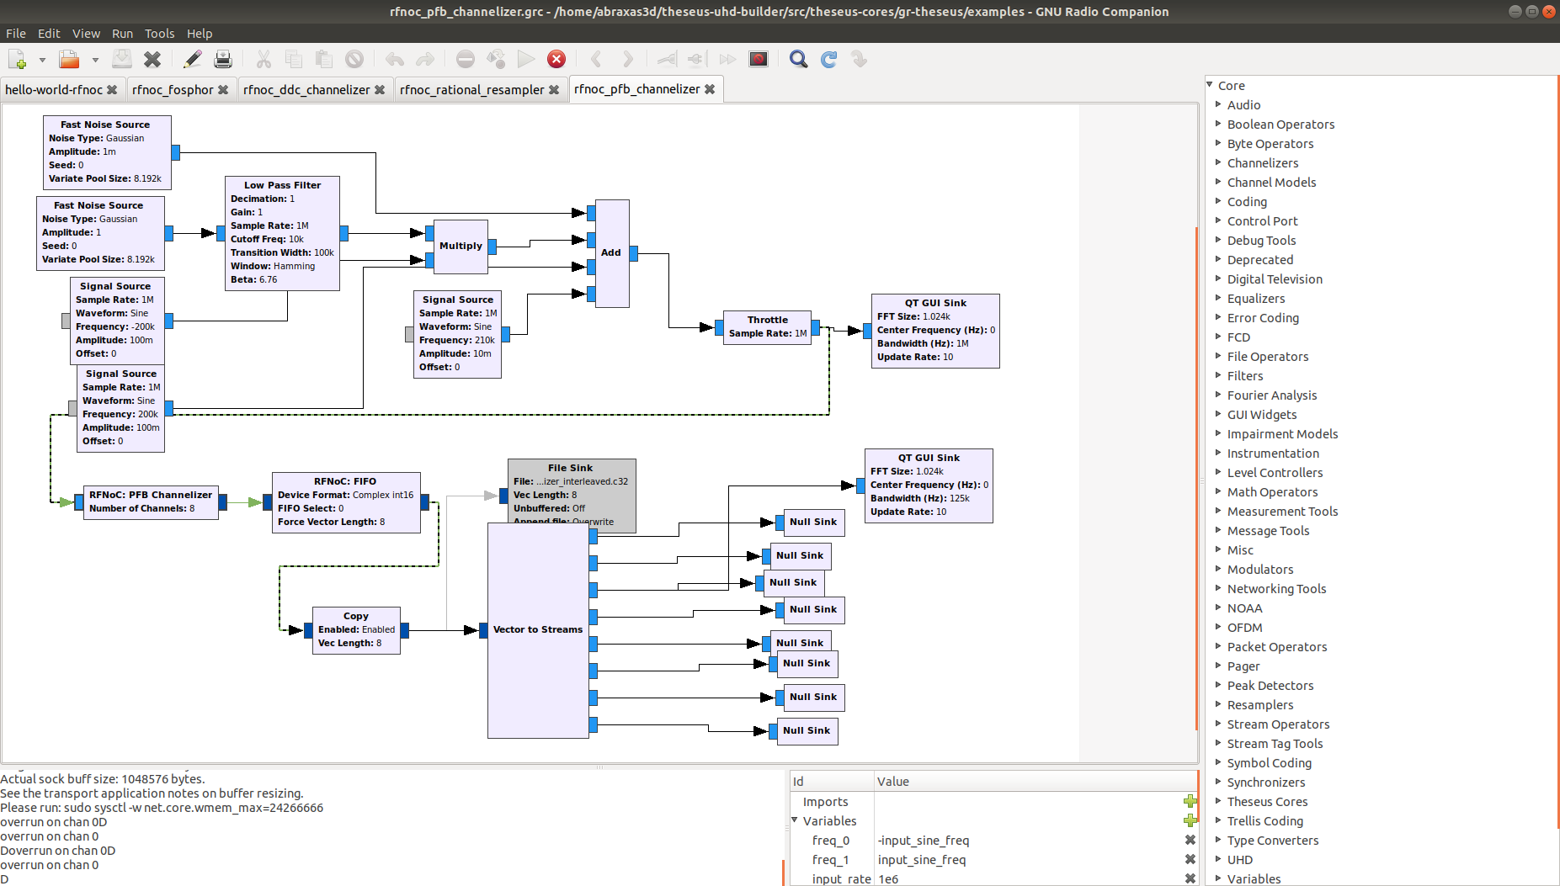

Note that the GUI is hard-coded to show only one of the eight channels.

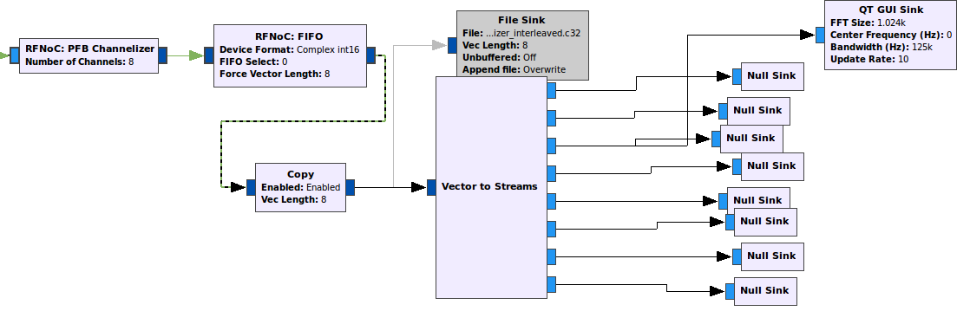

This is a good first demonstration. We do want operators to be able to pick up one, several (for a conference), or all, of the channels. One particular channel at a time can be viewed right now, with the blocks we have. We need to configure the blocks, and get the RF hardware in order, test it over the in in the lab, and put it on the air at the mountain site.
Ron Economos W6RZ explained that one can have multiple inputs on the QT GUI Frequency Sink. Here’s an example flowgraph and output:

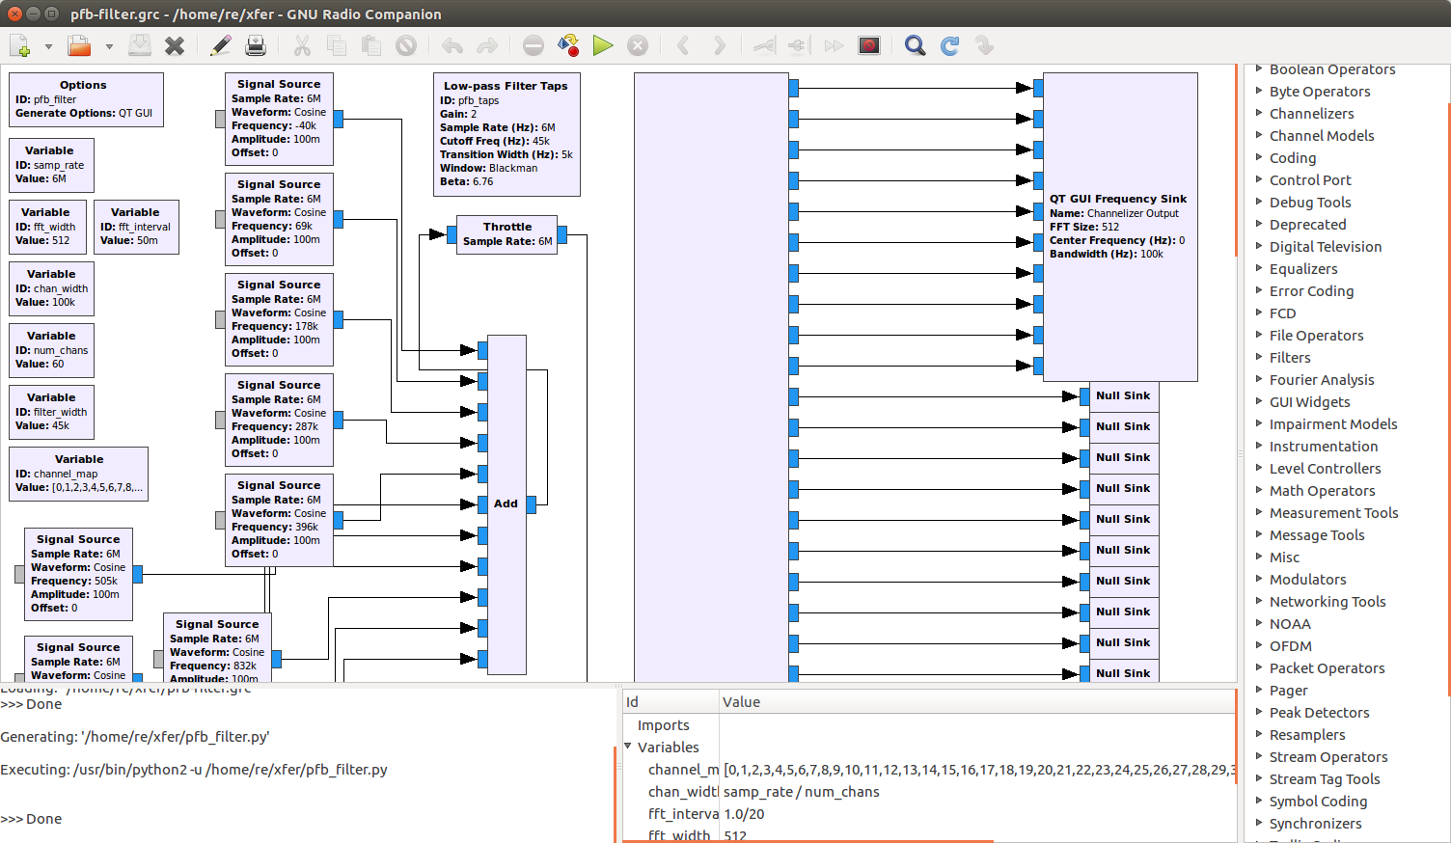
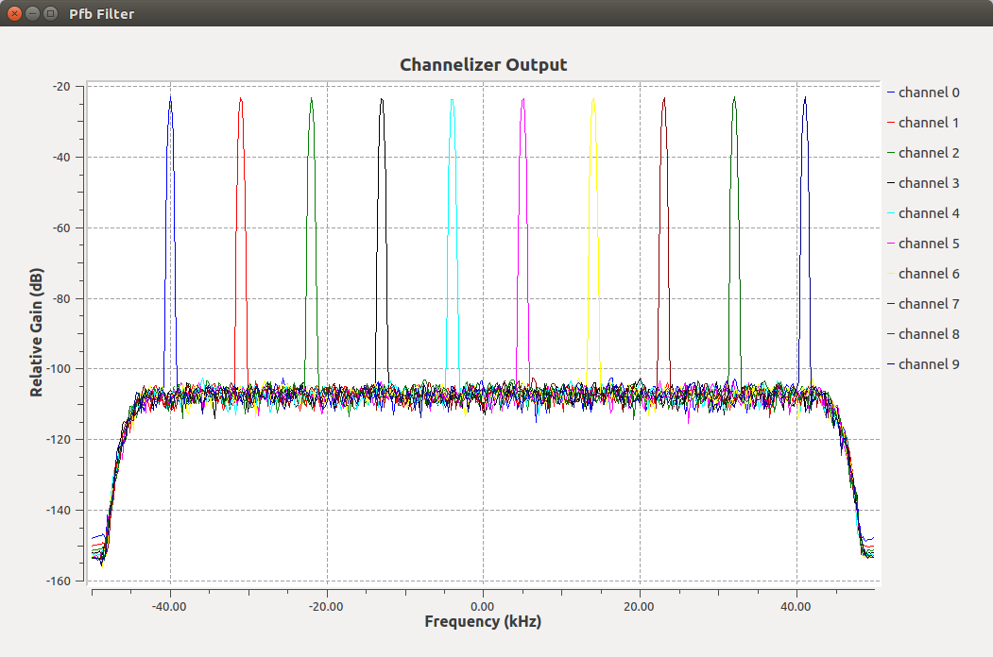
This technique was used to modify the example channelizer flowgraph from Theseus Cores.

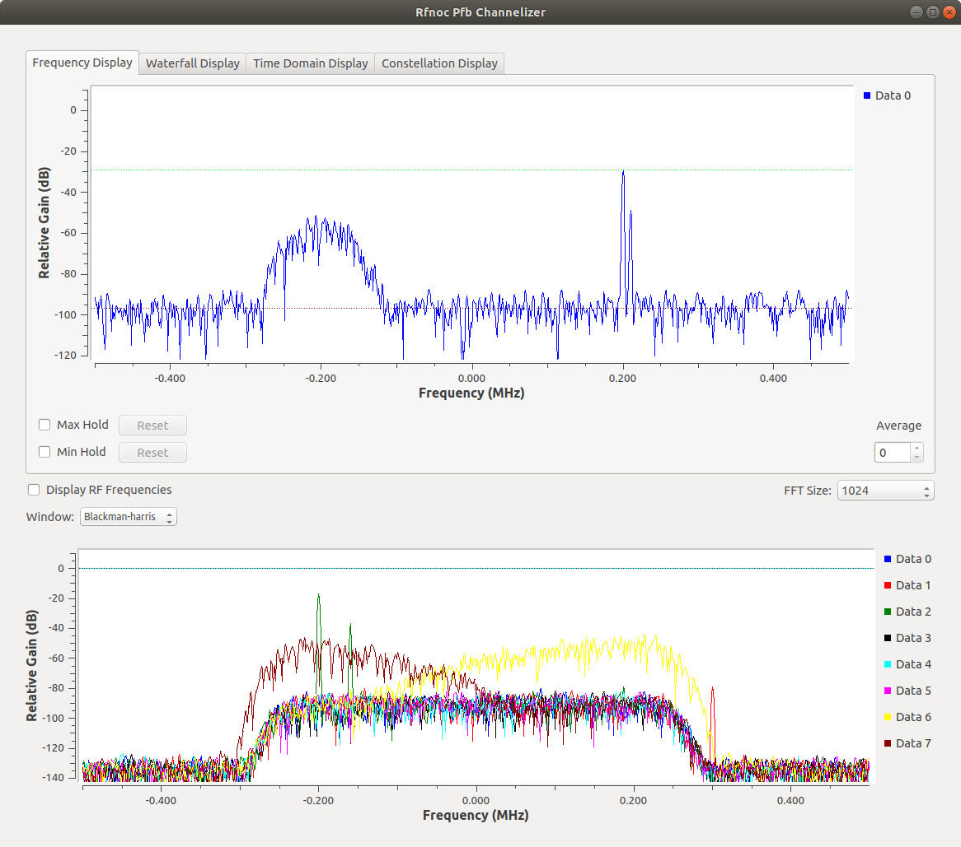

However, according to:
https://kb.ettus.com/RFNoC#GNU_Radio
the graph really has to have a DDC after RFNoC Radio.
A DDC block was placed, but now that block could not be found.
A false lead was to add the dsp-utils module and the pfb channelizer module (i.e. both Theseus Cores) to uhd_image_builder. This didn’t add in the right DDC, but all three blocks appeared in uhd_usrp_probe results.
Command: AI can’t find it in history, confirm
Output from uhd_usrp_probe:

| | _____________________________________________________
| | /
| | | RFNoC blocks on this device:
| | |
| | | * DmaFIFO_0
| | | * Radio_0
| | | * Radio_1
| | | * FIFO_0
| | | * FIFO_1
| | | * Block_0
| | | * DUC_0
| | | * DUCDDC_0
| | | * DDC1TON_0
| | | * pfbchannelizer_0

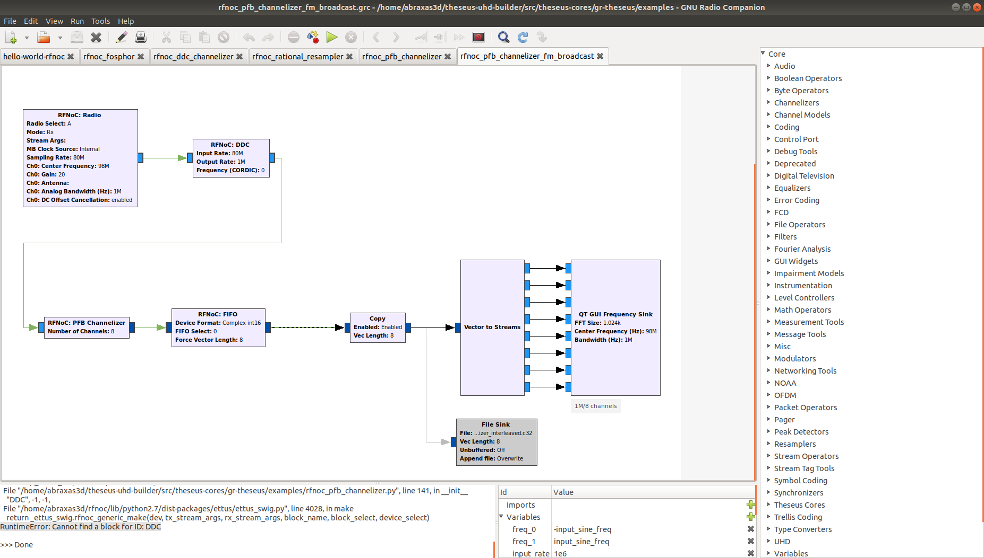

Problem: DDC block not showing up, but it is called out in the yml file.
- block: ddc
parameters:
NUM_CHAINS: 2
NOC_ID: 64'hDDC0_0000_0000_0002
hints:
- ddc2
EJ recommended to remove all the parameters, leaving only the line:

- block: ddc

So that was done and the image was rebuilt.
python src/uhd-fpga/usrp3/tools/scripts/uhd_image_builder.py -d x310 -t X310_RFNOC_HG -y build-configs/everything.yml -I src/theseus-cores/fpga-rfnoc/m2_channelizer src/theseus-cores/fpga-rfnoc/dsp-utils

The image was loaded.

/home/abraxas3d/rfnoc/bin/uhd_image_loader --args "type=x300,addr=192.168.10.2" --fpga-path /home/abraxas3d/theseus-uhd-builder/src/uhd-fpga/usrp3/top/x300/build/usrp_x310_fpga_RFNOC_HG.bit

X310 was rebooted, uhd_find_devices, and then uhd_usrp_probe.
The RFNoC blocks now on the FPGA:
| | _____________________________________________________
| | /
| | | RFNoC blocks on this device:
| | |
| | | * DmaFIFO_0
| | | * Radio_0
| | | * Radio_1
| | | * FIFO_0
| | | * FIFO_1
| | | * DDC_0
| | | * DUC_0
| | | * DUCDDC_0
| | | * DDC1TON_0
| | | * pfbchannelizer_0

Flowgraph now ran and channels seemed to have data in them. Another step forward.
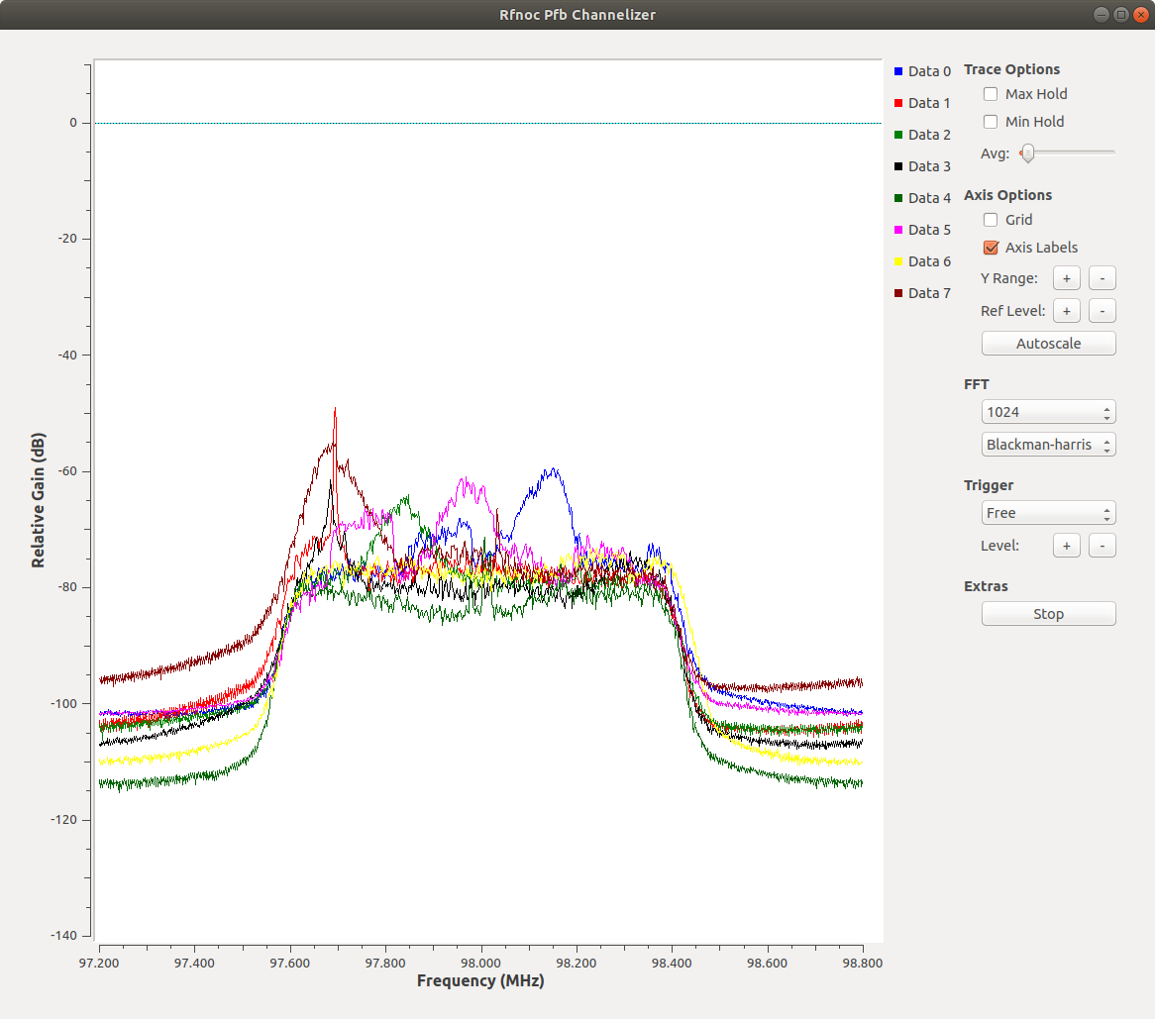
New problem: flowgraph eventually freezes and times out.
timeout on chan 0
timeout on chan 0
timeout on chan 0
timeout on chan 0
timeout on chan 0

>>> Done

Removing the copy block didn’t solve it. Copy block is used most often in RFNoC to connect more than one GNU Radio block to the output of a final RFNoC block.
Replacing the GUI block with null sinks and disabling the GUI block didn’t solve it.

